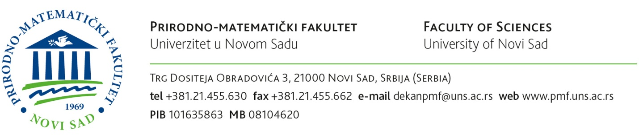

Based on the open competition for admission to master academic studies for academic 2026/2027 year, I herewith submit

APPLICATION

for enrolment in the Faculty of Sciences in Novi Sad, Department of ___________________________________
_______________________________________ to master academic studies study programme of _______________________________________, module ________________________________________________________________.

CANDIDATE’S PERSONAL INFORMATION

- Surname (father’s name) and first name: ___________________________________________________________________________
- Birth date:
________________________________________________________________________________________
- Place of birth, municipality (county) and country: ____________________________________________________________
- Nationality: ____________________________________________________________________________________________
- Gender (put X next to your choice): а) male b) female

- Data on previous studies
- Name of the higher education institution: _____________________________________________________
- Place of the higher education institution (city, country): _____________________________________
- Study programme/module: ____________________________________________________________________
- Year of enrolment: _____________________________________________________________________________
- Year of completing studies and graduation: __________________________________________________
- Duration of studies (in years and months): ____________________________________________________
- Grade point average during the studies: ______________________________________________________
- Number of ECTS acquired: ______________________________________________________________

- Occupation: ___________________________________________________________________________________________
- Working position and institution: __________________________________________________________________
- Permanent address: __________________________________________________________________________________
- Contact phone number:
home:____________________; work:____________________________ ; mobile: ___________________________
11. Е-mail:

Together with this Application, the following is enclosed:

1. Certificate on previously completed level of studies (or a confirmation of the Certificate);
a) original b) certified copy
(put X next to your choice)
2. Academic Transcript of Records with grade point average
3. Curriculum of the previously completed study level for students outside the Faculty of Sciences
4. Birth certificate
5. Proof of the procedure fee payment

Novi Sad, date: ______________

Applicant:

________________________________
(signature)

IMPORTANT: ALL original documents in the Applicant’s native language (if other than English) must be translated in English (or where required in Serbian) by a certified court interpreter to be accepted as eligible.

Certificate(s) on completed undergraduate studies needs to be recognized in order to continue studies at the University of Novi Sad. This procedure is done by the University of Novi Sad and it may take some time. Applicants are strongly advised to submit the documents as soon as possible. It is possible to get the written confirmation that the procedure is started in order to enclose it in the application together with other documents. This is obligatory part of the application procedure.
The list of necessary documents, information on fees and further detailed instructions can be found in the following link: https://www.uns.ac.rs/index.php/en/studies/recognition-of-diplomas/recognition-of-foreign-diplomas
Application form: Application for the recognition of a foreign higher education document
Contact email: priznavanje@uns.ac.rs; rektorat@un.ac.rs

The Application should be duly filled in, signed by the Applicant and emailed (as an attached scan) to the following email address: iro@pmf.uns.ac.rs

*Please bear in mind that dates may vary. Please check for updates prior to submission.

N.B. Links in this Application Form are active.

